**System Planning and Process**

Joshua Farrell

January 28, 2025

### 

### 

### **Optimizing Digital Marketing Strategies for a Retail DTC Model**

I designed a system to optimize digital marketing strategies for a retail company transitioning to a direct-to-consumer (DTC) model. The system leverages audience segmentation, campaign automation, and performance tracking using advanced analytics tools such as Google Analytics, Meta Ads Manager, Google Tag Manager, and Reddit Ads. By incorporating A/B testing, predictive analytics, and automated tag management, this system aims to improve Return on Ad Spend (ROAS), conversion rates, and customer engagement.

My system focuses on enhancing digital marketing strategies for a retail business shifting to a DTC model. Key objectives include improving ROAS by targeting the right audience with optimized ad creatives, using analytics to track customer behavior and engagement, automating campaign management for efficiency and scalability, and integrating multi-platform marketing across Google, Meta, and Reddit. By utilizing data-driven marketing techniques, I ensure that ad spend is optimized, conversion rates are maximized, and marketing insights drive continuous improvement.

### **Project Management Approach and PMBOK Integration**

I adhered to the principles outlined in the *Project Management Body of Knowledge (PMBOK Guide)* to ensure structured planning, execution, and monitoring. The five phases of the project—Initiating, Planning, Executing, Monitoring & Controlling, and Closing—provided a clear framework for managing scope, cost, and time effectively. Risk assessment, stakeholder management, and performance metrics followed PMBOK methodologies to maintain alignment with the project’s objectives.

### **Stakeholder Engagement Assessment Matrix**

To align all stakeholders with the project goals, I developed a Stakeholder Engagement Assessment Matrix. Stakeholder groups included customers who were initially unaware of the DTC transition, the sales team who needed support to adapt to the new model, executive leadership and external agencies who required regular updates to build confidence, and the marketing team who played a key role in executing the plan. Each group had tailored engagement strategies to enhance their involvement and contributions.

**Figure 1: Stakeholder Engagement Assessment Matrix** **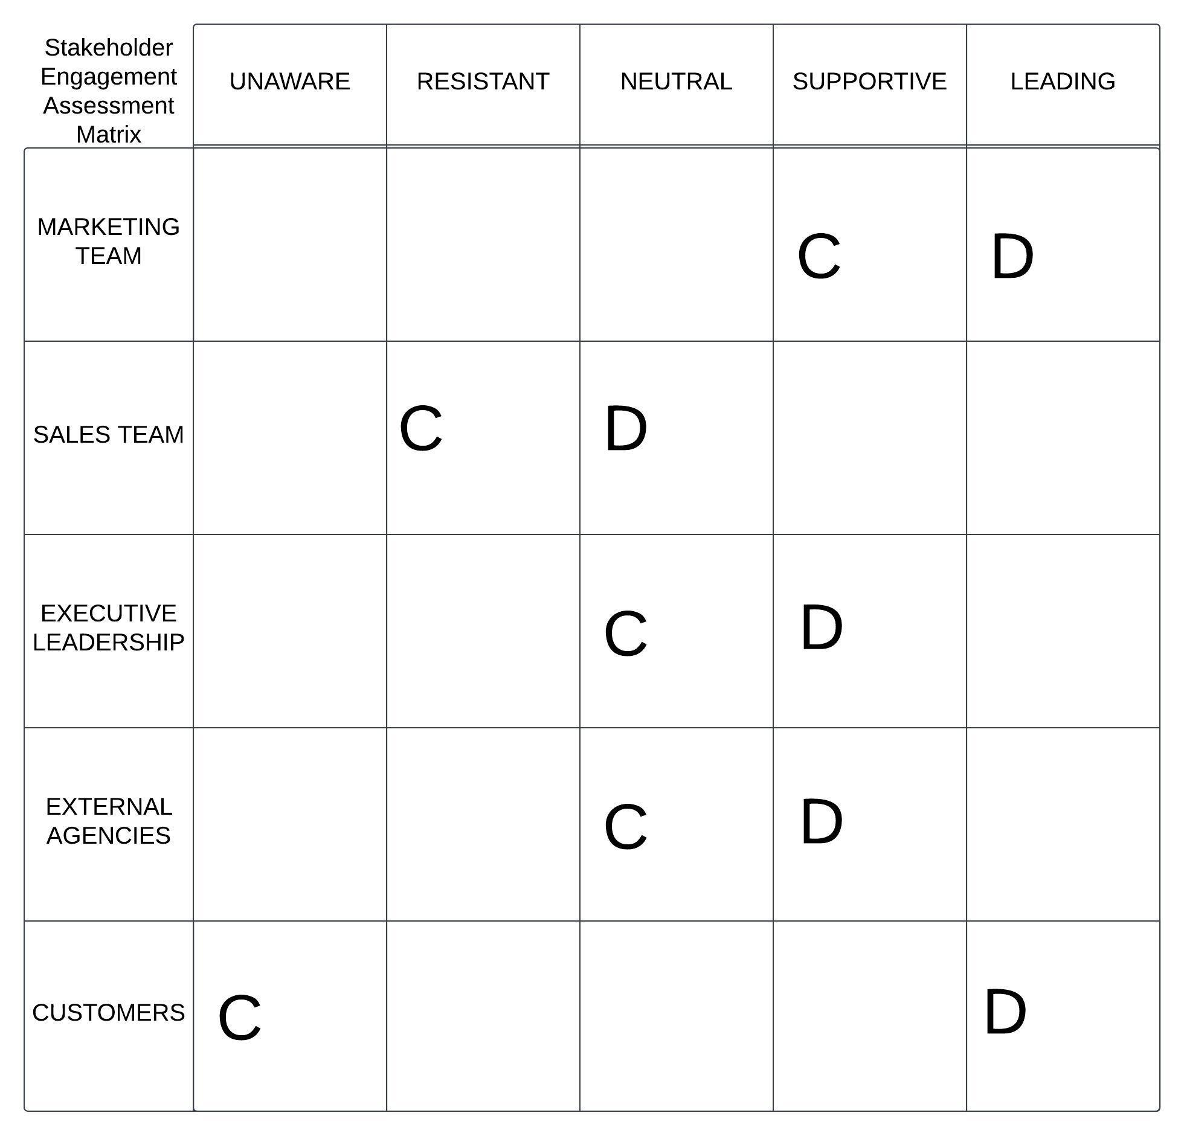  
 C= Current Engagement, D= Desired Engagement**

### **Project Plan**

My project plan included a detailed scope, work breakdown structure (WBS), timeline, budget, and performance metrics. The objective was to launch a high-performing ad campaign targeting ROAS > 4 for Google Ads and CTR > 3% for Meta Ads. The WBS covered campaign setup, creative development, audience targeting, ad testing and optimization, performance analysis and reporting, and scaling successful campaigns. The timeline followed a six-week roadmap, and the monthly budget was set at $12,575 to cover ad spend, content development, and analytics tools.

**Figure 2: WBS**

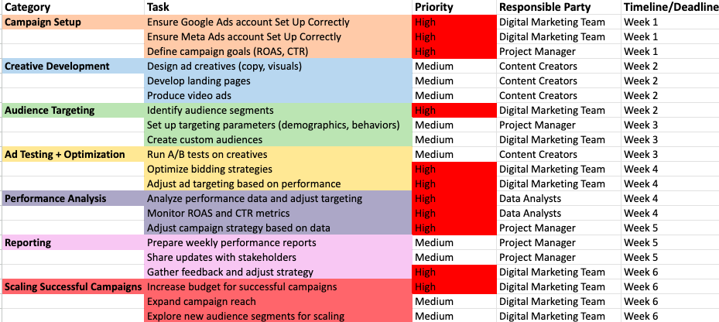

**Figure 3: Budget Allocation** 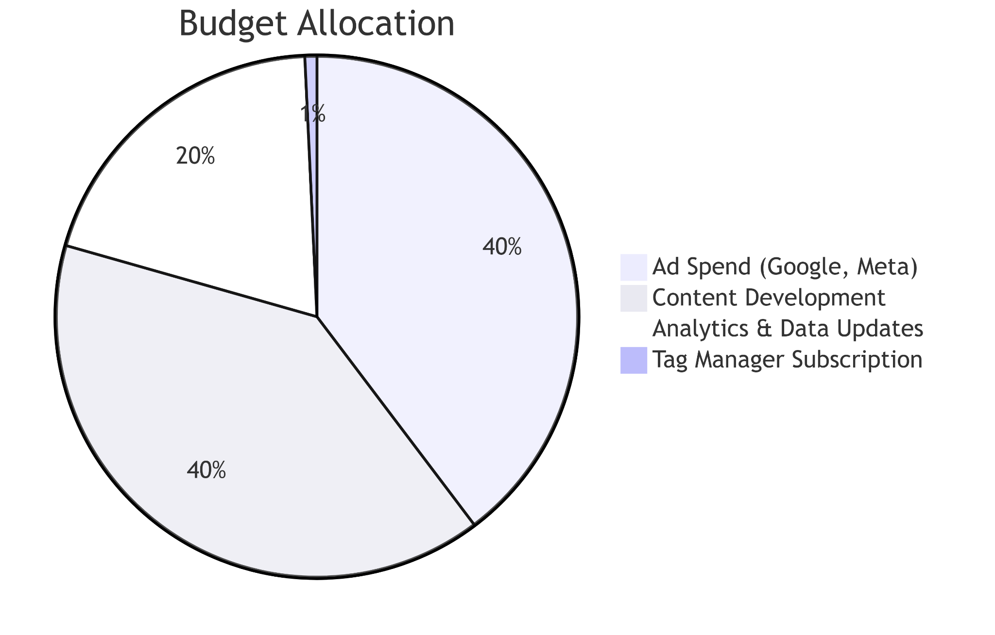

### **Design Methodology and Timeline**

I followed a five-phase design methodology: Inception (Google/Meta Ads account setup, product feed integration), Analytics Implementation (sales funnel tracking, tag testing), Development (landing page creation, ad creative production), Launch & Testing (ad deployment, A/B testing, real-time monitoring), and Maintenance & Optimization (ongoing adjustments to bidding, targeting, and creatives). The Gantt chart visually represented overlapping tasks to ensure an efficient workflow.

**Figure 4: Gantt Chart - Project Timeline** 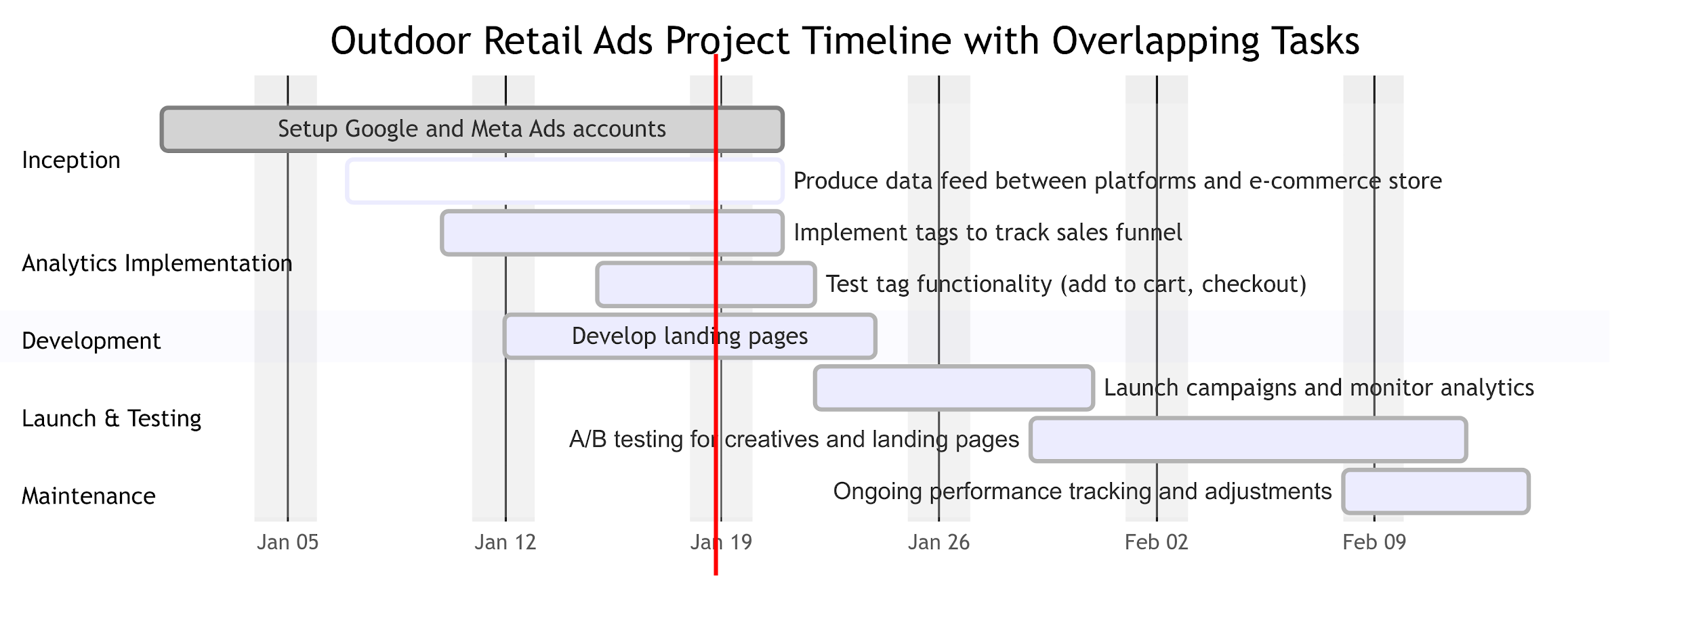

### **Risk Matrix**

I identified key risks and implemented mitigation strategies to ensure project success. Risks included blizzards affecting timelines, website connection issues, budget constraints, factory strikes impacting product availability, and tag and pixel implementation issues. For example, I built buffer time into the schedule to account for weather delays and implemented hosting redundancy to address website issues. These proactive measures helped the project stay resilient and meet its goals.

**Figure 5: Risk Matrix**

| **Risk** | **Likelihood** | **Impact** | **Severity** | **Mitigation Plan** |
| --- | --- | --- | --- | --- |
| Blizzard affecting timelines | Medium | High | High | Build buffer time into the schedule; identify alternative transportation or backup options. |
| Electricity loss | Low | High | Medium | Ensure backup generators are available and test them regularly. |
| Budget constraints | Medium | High | High | Monitor spending closely; allocate contingency funds and re-evaluate non-essential expenditures. |
| Website contractor quits | Medium | Medium | Medium | Maintain updated documentation; onboard a secondary contractor or identify a backup. |
| Website outage | Medium | High | High | Implement hosting redundancy; ensure regular backups and monitoring for uptime. |
| Factory strike | Low | High | Medium | Foster good communication with workers; create an emergency contingency plan. |
| Products not arriving in time | Medium | High | High | Communicate frequently with suppliers; build buffer time into the schedule; identify backup vendors. |
| Tag and pixel issues | Medium | Medium | Medium | Involve experienced developers; schedule regular testing and troubleshooting sessions. |

### **Conclusion**

This project followed a structured lifecycle from inception to optimization. By aligning with PMBOK principles, I ensured that marketing efforts met business goals, optimized ad spend through data-driven decision-making, and continuously refined strategies for long-term success. Using tools like Google Analytics and Meta Ads, coupled with a focus on stakeholder engagement and risk mitigation, I created a system that enhanced digital marketing strategies for the company’s DTC transition.

This framework demonstrates how automation, analytics, and structured planning can drive efficiency, maximize conversions, and ensure scalability.

Project Management Institute. (2021). *A Guide to the Project Management Body of Knowledge (PMBOK Guide) – Seventh Edition*. Project Management Institute.